**Experiment 2:**

**Equipment:**

**Multimeter Metrahit TRMS ADVANCE**

**UniCTor A43**

a. We set up a circuit like the picture below:

The potentionmeter

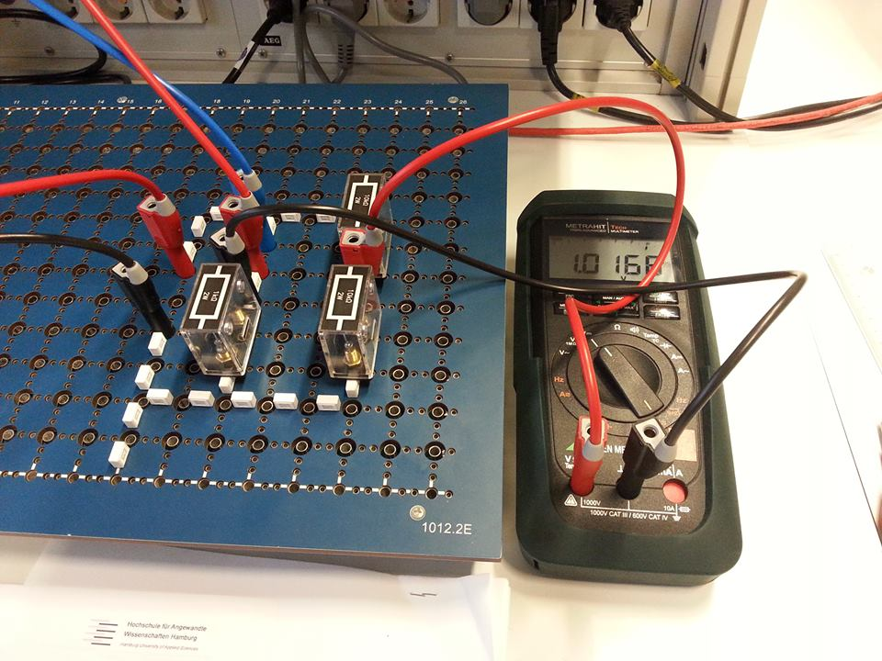

Power supply

Uo = 6V

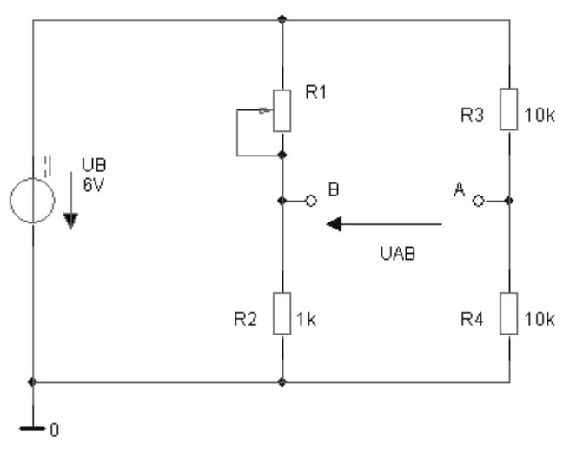

b. The bridge is balanced => $\frac{R4}{R3}= \frac{R2}{R1}$ => R1 = R3 $\frac{R2}{R4}$ = 1000 Ω

c. d.

|  |  |  |  |
| --- | --- | --- | --- |
| **R1 Ω** | **UAB (V) Calculated** | **UAB (V) Measured** | **r** |
| 550 | -0,8710 | -0,8589 | -0,45 |
| 750 | -0,4286 | -0,4143 | -0,25 |
| 1000 | 0,0000 | 0,0157 | 0 |
| 1250 | 0,3333 | 0,3498 | 0,25 |
| 1400 | 0,5000 | 0,5167 | 0,4 |
| 1700 | 0,7778 | 0,7946 | 0,7 |
| 2000 | 1,0000 | 1,0168 | 1 |

e. UAB = f(R1)

UAB (V)

f. E0 = = = 1.5 * 10-3